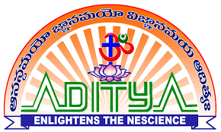 Aditya College of Engineering & Technology

Aditya Nagar, ADB Road, Surampalem – 533437

**Financial Assistance to Faculty Members**

**Academic Year 2022-23**

The following is the list of faculty members received financial support for attending Conferences/ Workshops/FDPs / Professional Body Memberships. The amounts are reimbursed as per the policy of the Institution.

|  |  |  |  |  |  |
| --- | --- | --- | --- | --- | --- |
| **S.No** | **Name of the Faculty** | **Dept.** | **Name of the Program** | **Type**  **of the Program** | **Amount** |
| 1 | Y.Alekhya | ECE | CONIT-2022, Hubballi,Karnataka, 24-26, June 2022 | Conference | 7,600 |
| 2 | I.Ramesh Raja | ECE | RDECS-2022, Aditya Engineering College, Surampalem 22-23, July 2022 | Conference | 15,000 |
| 3 | Dr.D.Kishore | ECE | ICCCI-2023, Sri Shakthi Institute of Engineering and Technology, Coimbatore, 23-25 Jan 2023 | Conference | 7,000 |
| 4 | Dr.R.Anil Kumar | ECE | ICOEI 2023 ,SCAD college ofEngineering and Technology,Tirunalveli,11-13 April 2023 | Conference | 7,500 |
| 5 | V.Preethi | ECE | IICI 2023,Nalanda,BEI Academy of Excellence,Bengaluru,3-5 May 2023 | Conference | 4,000 |
|  | Total | | | | 41,100 |